Cache:

First Level cache:

When you fire two setName on persistence object it will not fire two update queries.

This is first level cache.

Minium no of queries to be run

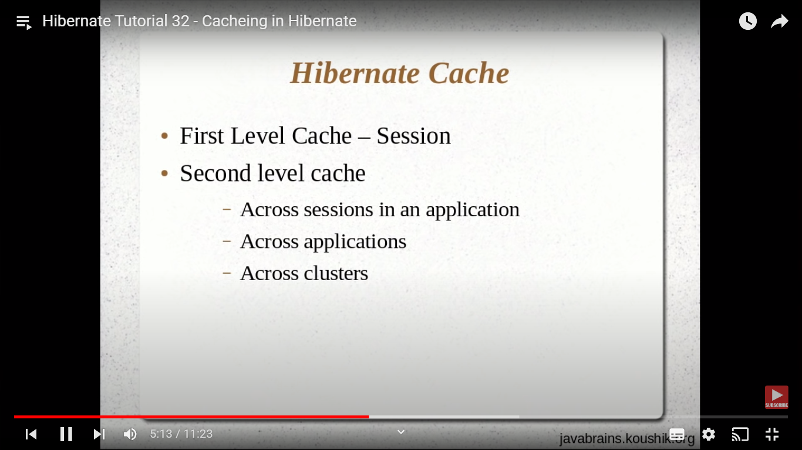

Lets check first level cache :

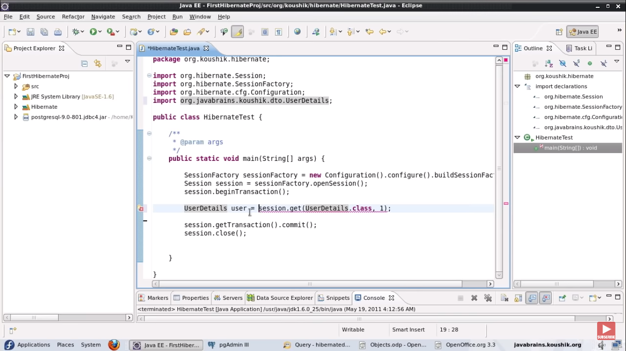

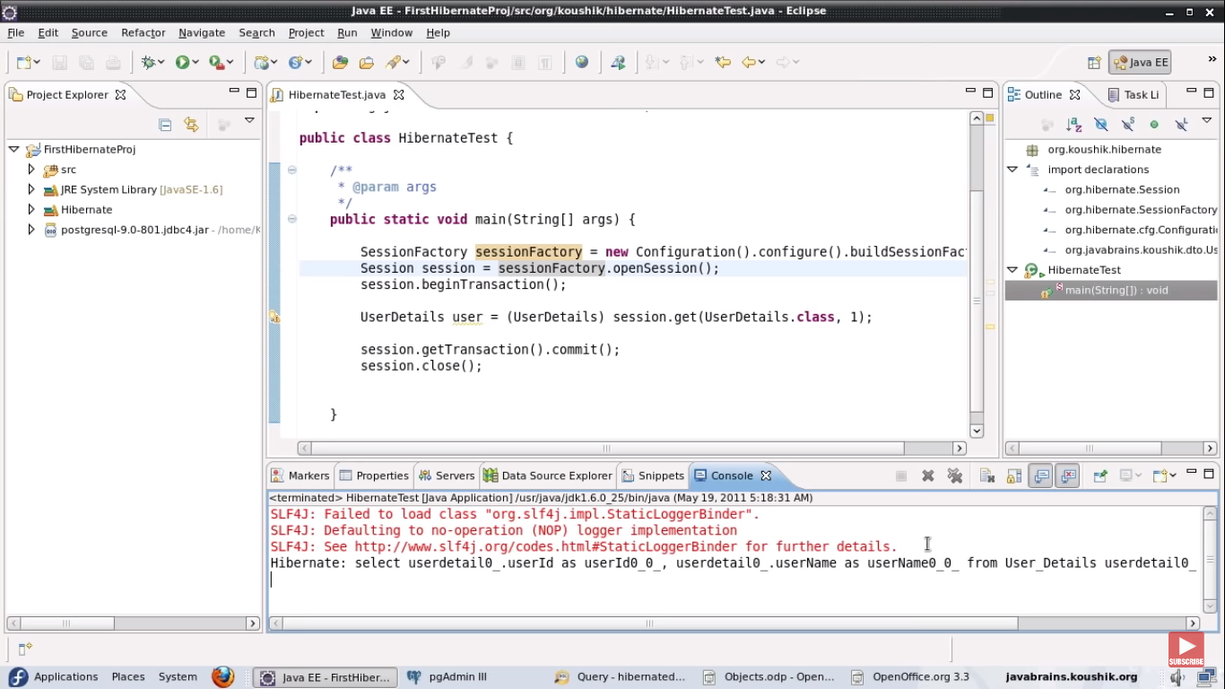

Getting the same object second time :

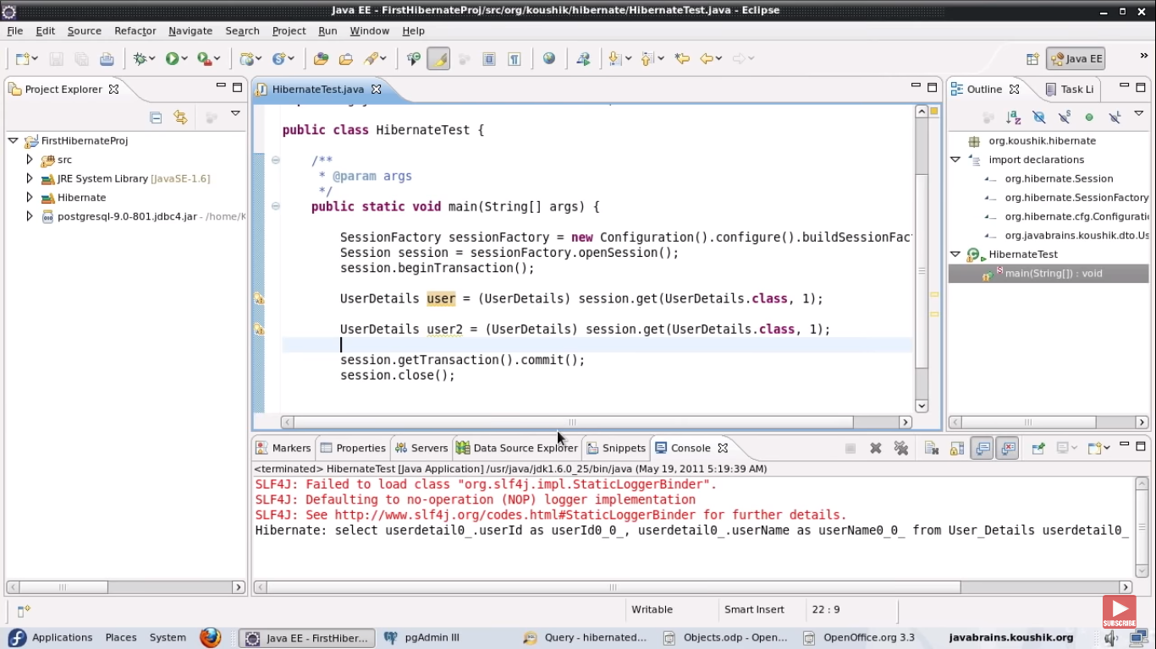

Still its one select .

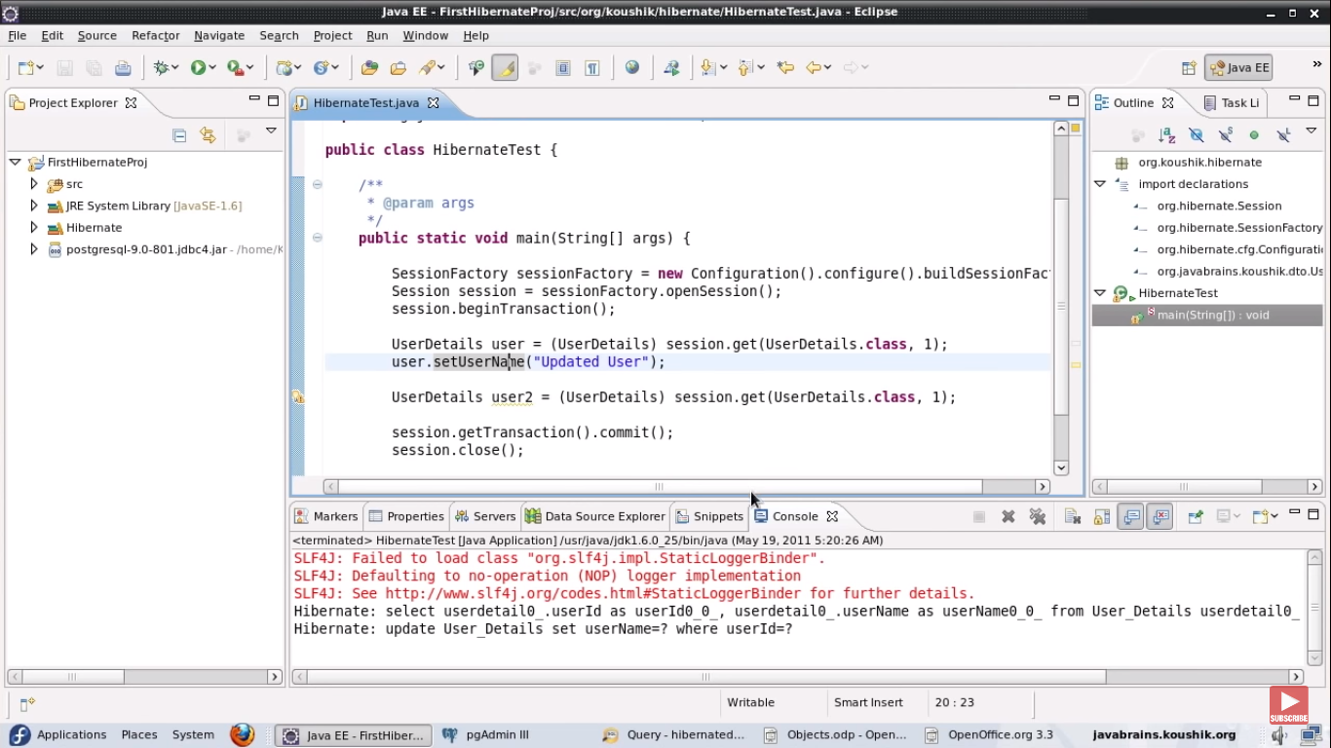

One select and one update.

Already hibernate has the updated object in cache so it will not fetch it again from DB.

But if we are getting same UserDetails Object in different sessions then there will be two queries. Because the session is closed so cache is removed.

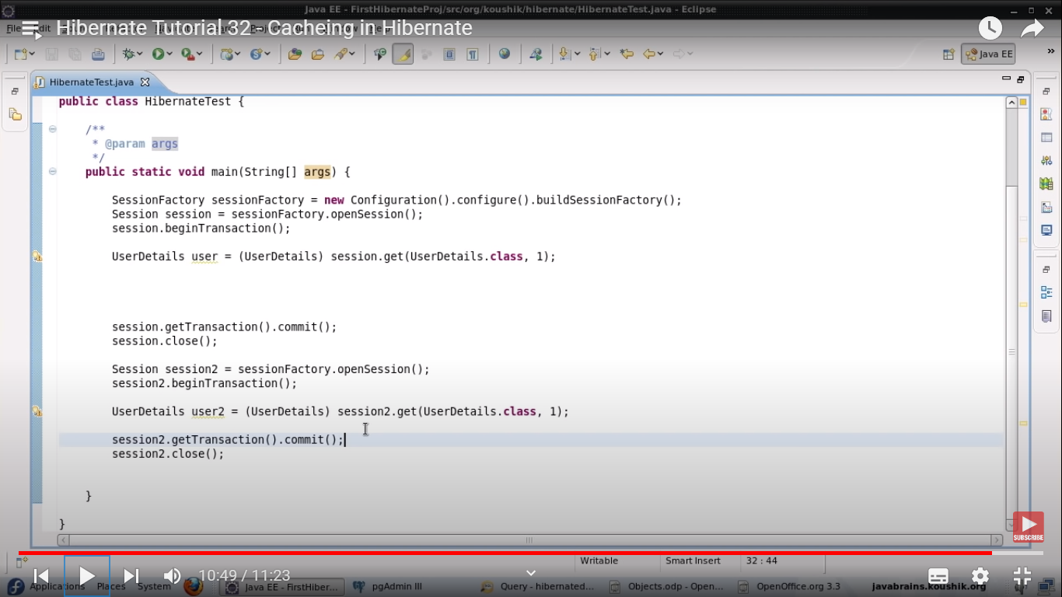

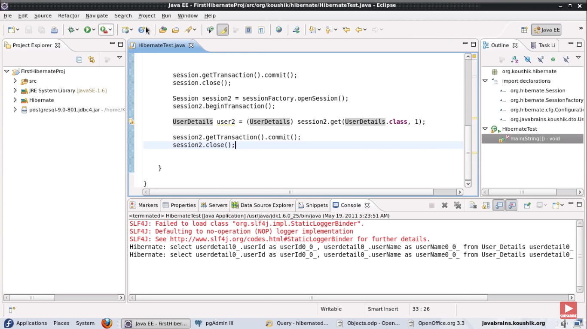

Solution is second level cache.

So idea is hibernate will look the object in First level cache if its not there then it will look into second level cache.and if it’s found then returns it.

How to configure ?

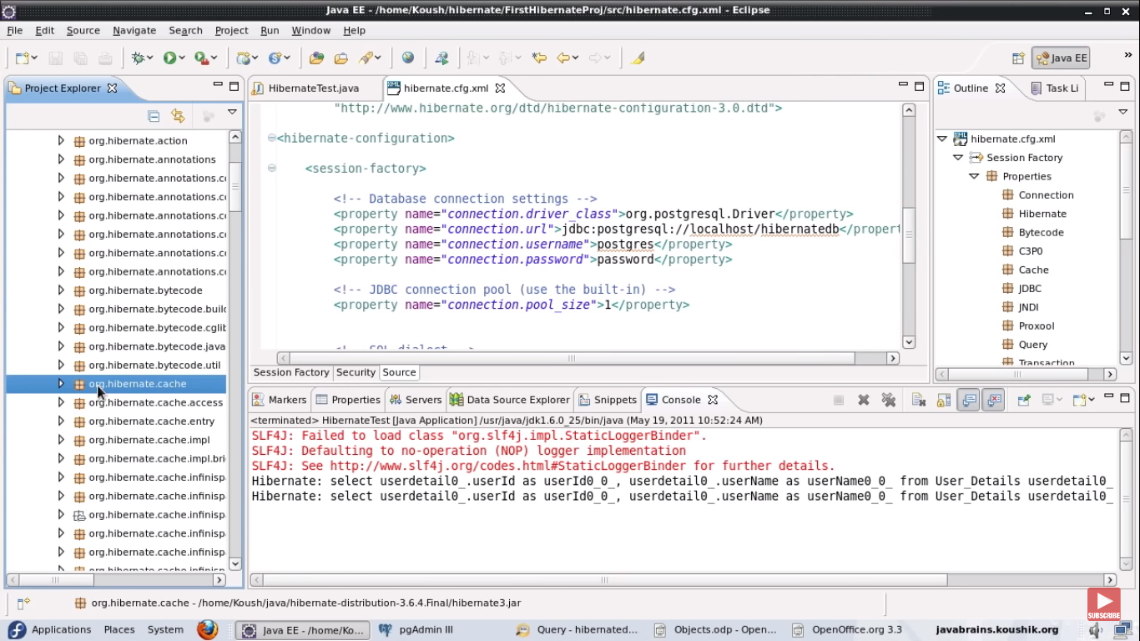

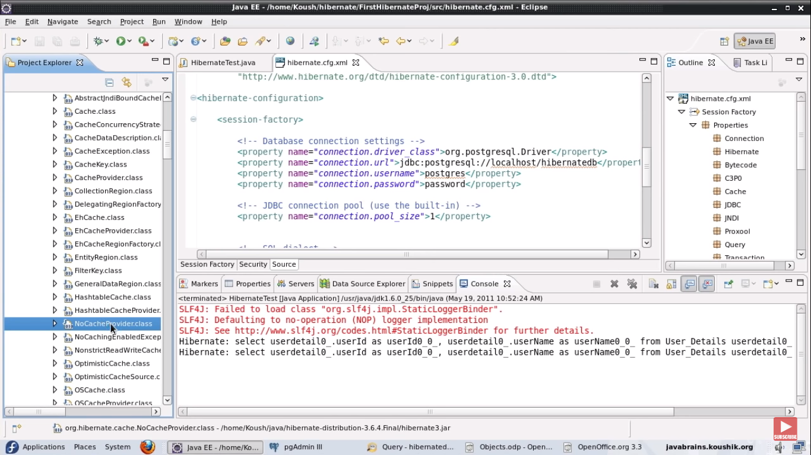

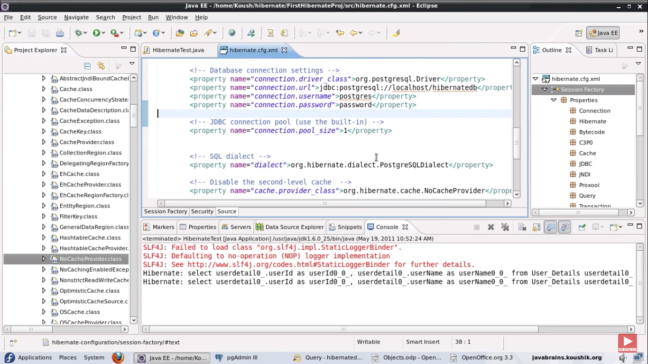

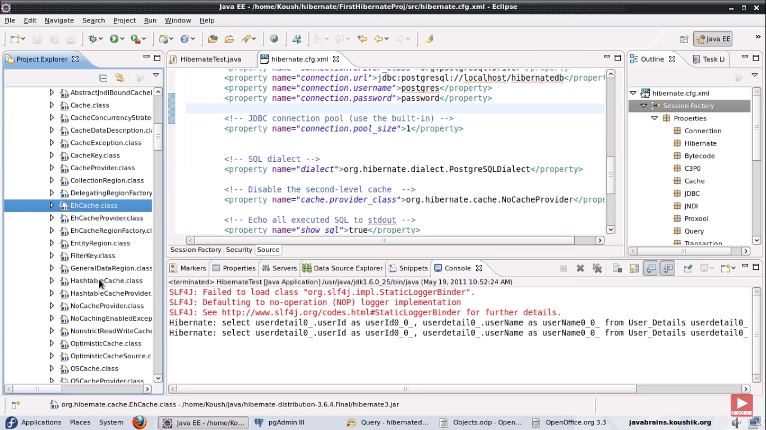

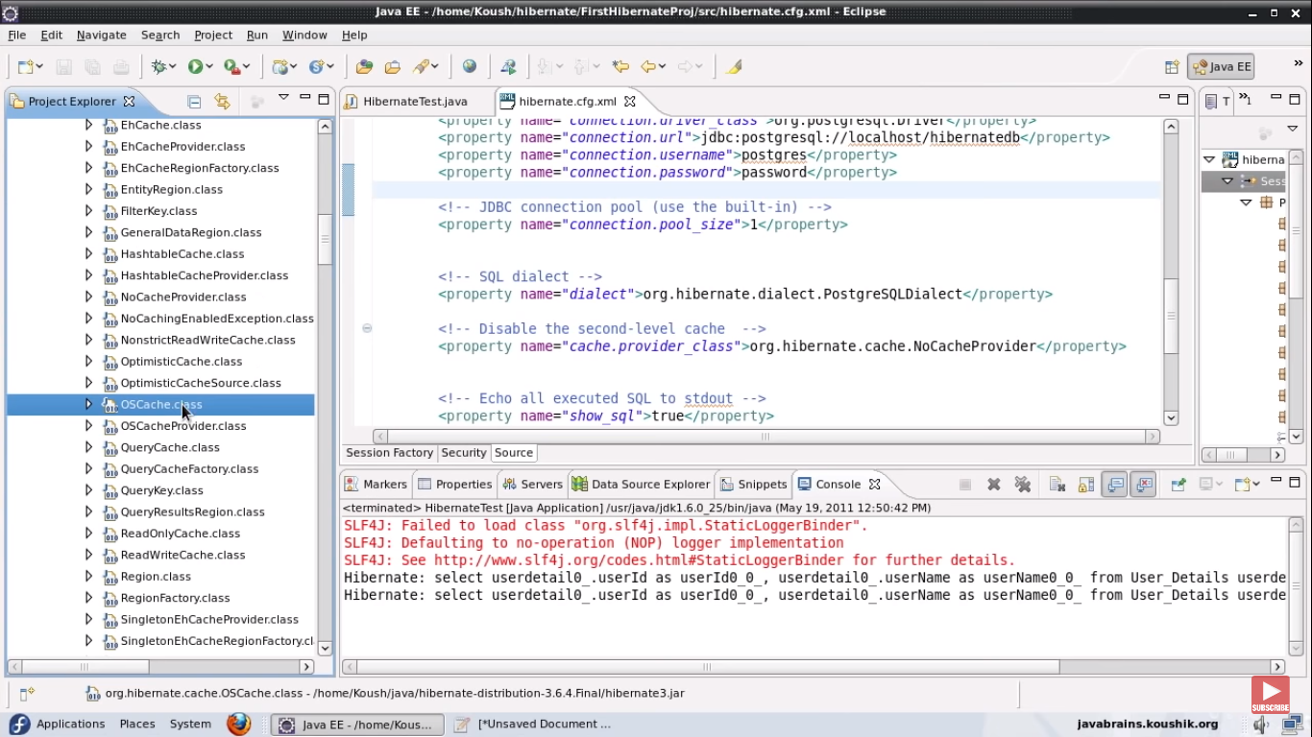

Use ehcache instead of nocache provider.

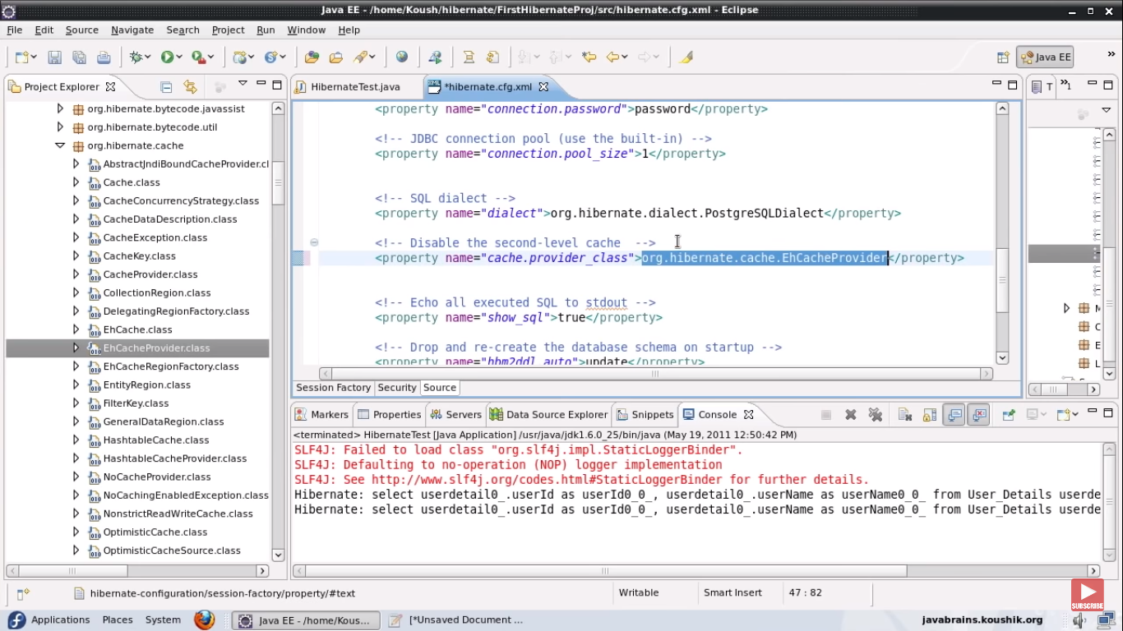

Also set property to true .

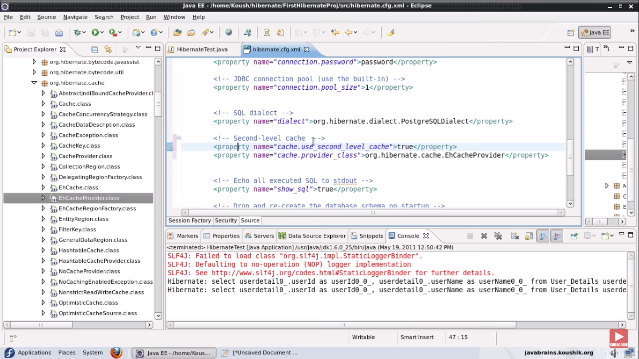

Download ehcache

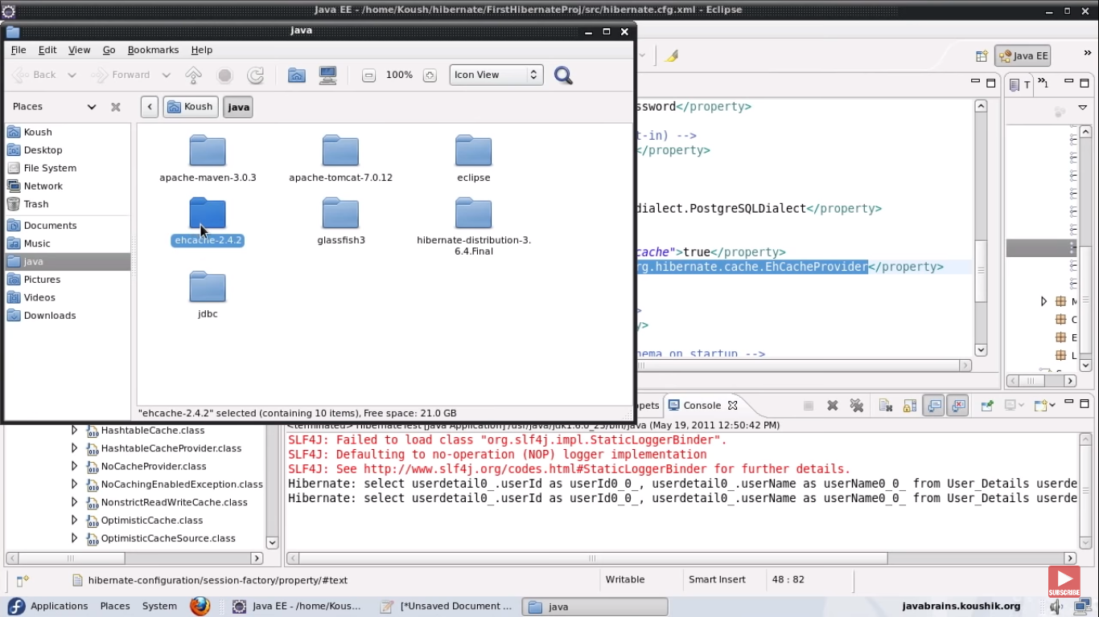

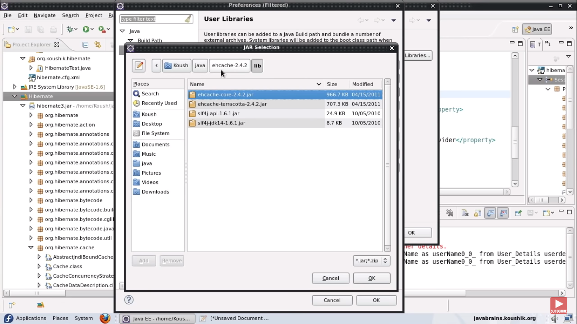

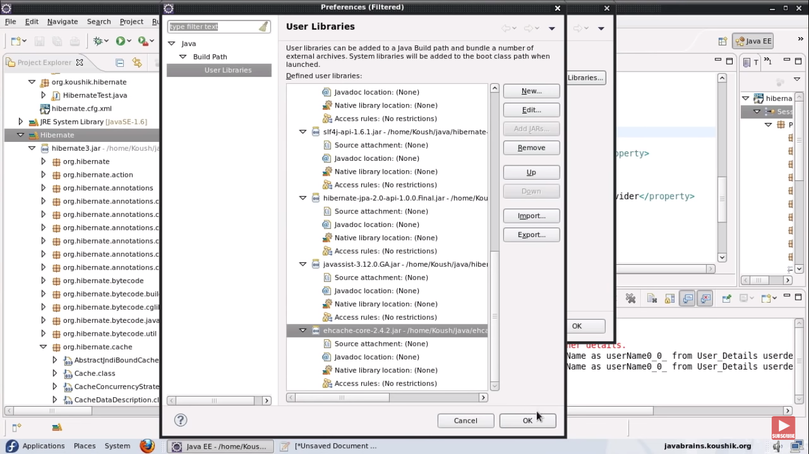

Added jar to classpath.

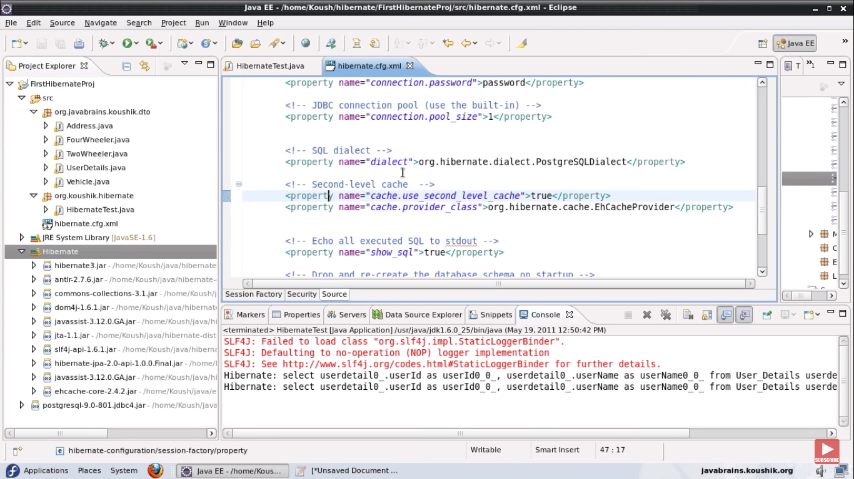

Use @Cacheable annotation on Entity also mention caching strategy .

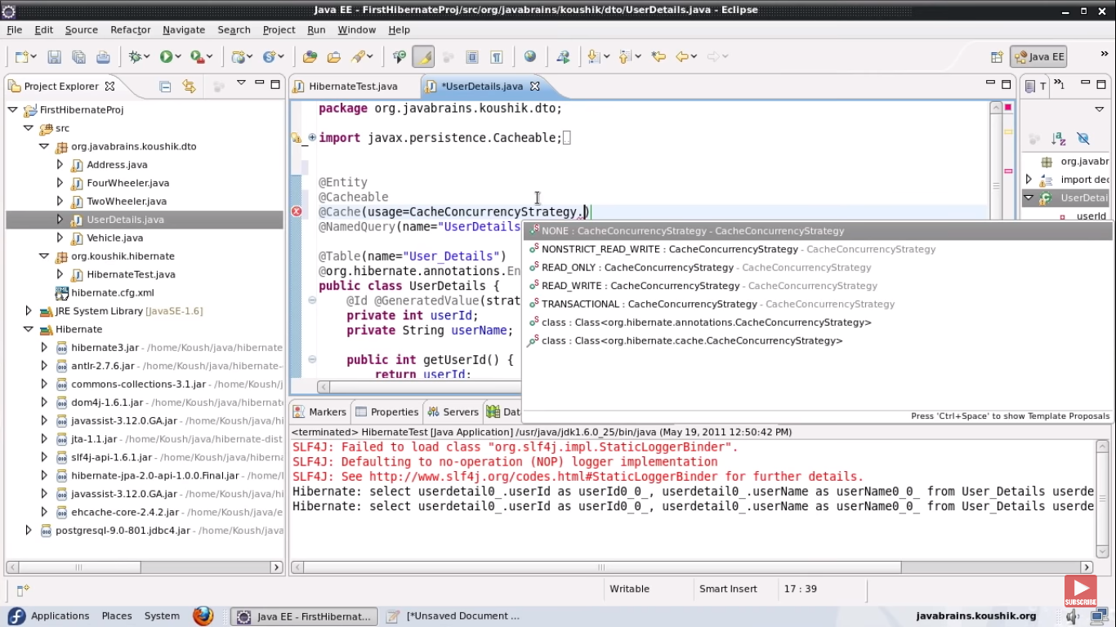

We have multiple options

READ_ONLY -> if we are not writing any data to DB use this.

READ_WRITE -> if we are writing data to DB then use this.so once we write data to DB its updated in cache as well.

TRANSACTIONAL -> Caching per transaction based. not that much useful

NON_STRICT_READ_WRITE -> chances are there that we might get old data when we read from cache.

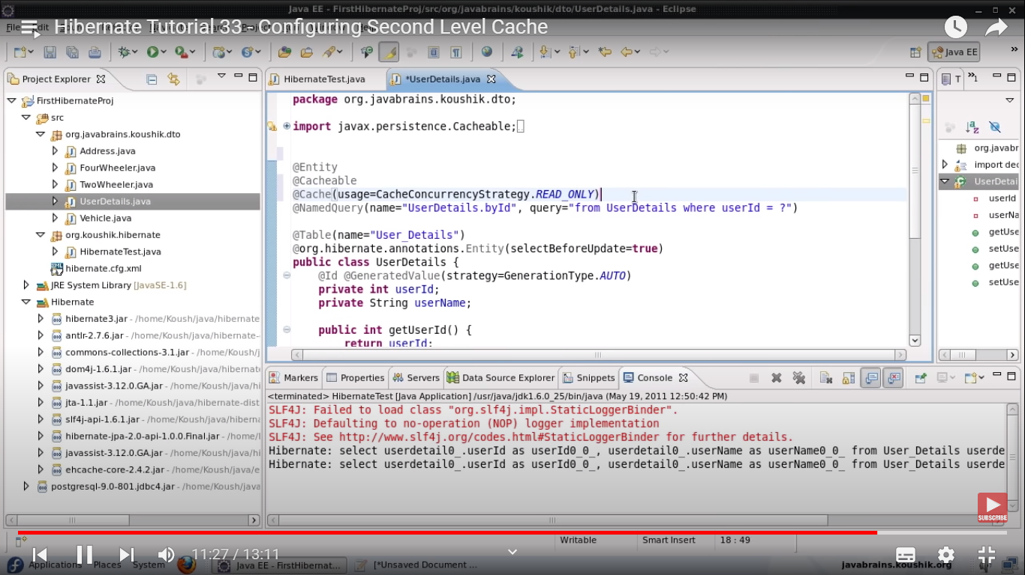

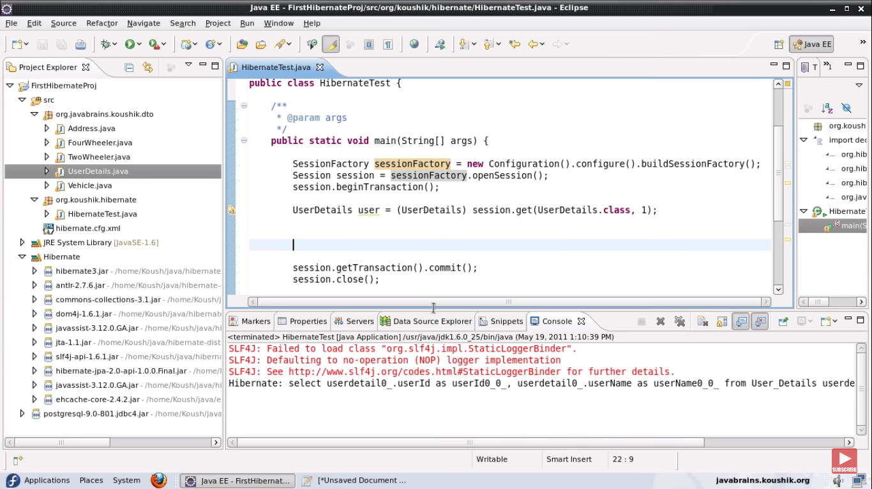

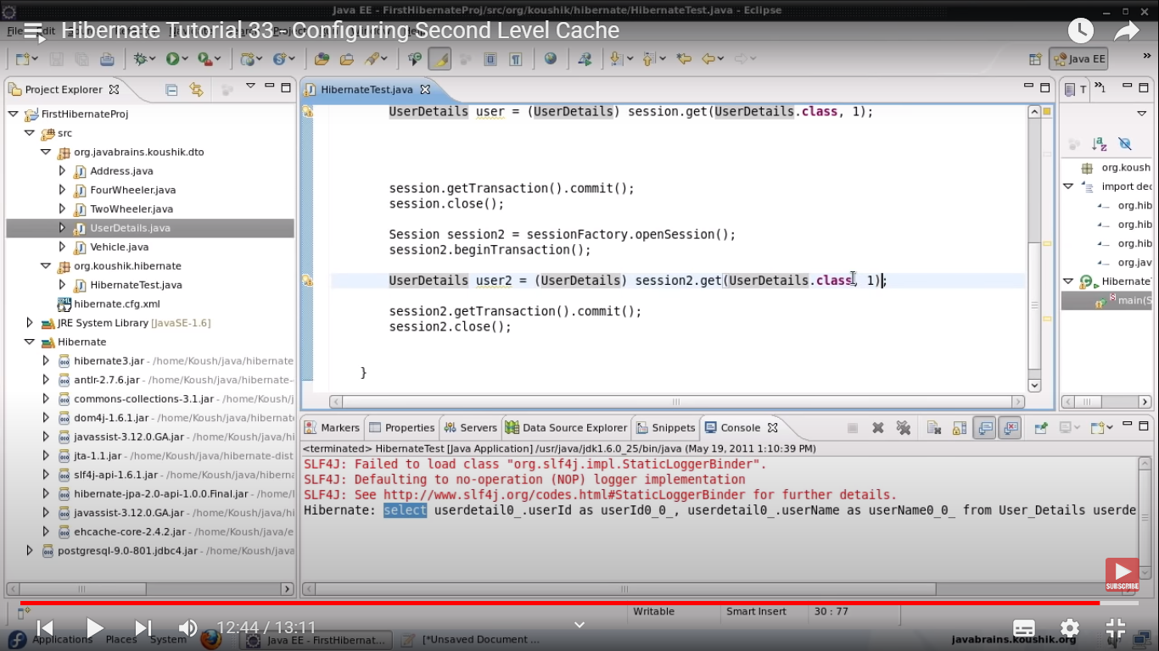

Here you can see only one select.

Hibernate has added the UserDetails object to 2nd level cache.

So when we do session2.get it will check in second level cache.

Query cache :

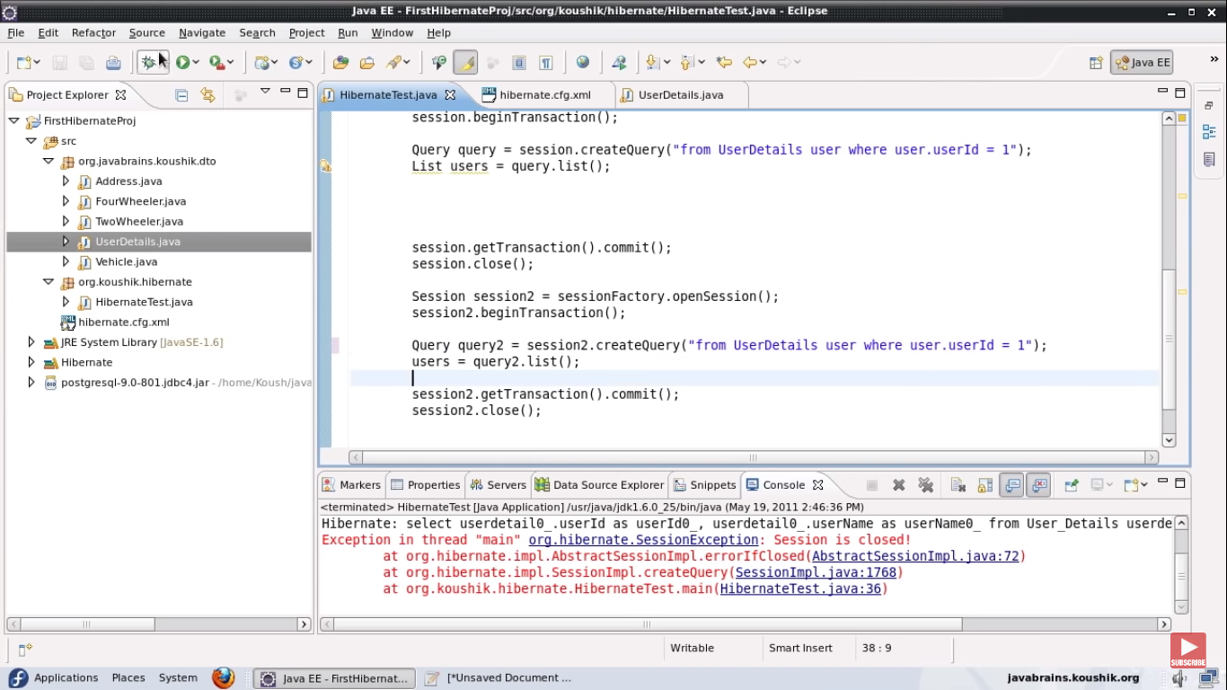

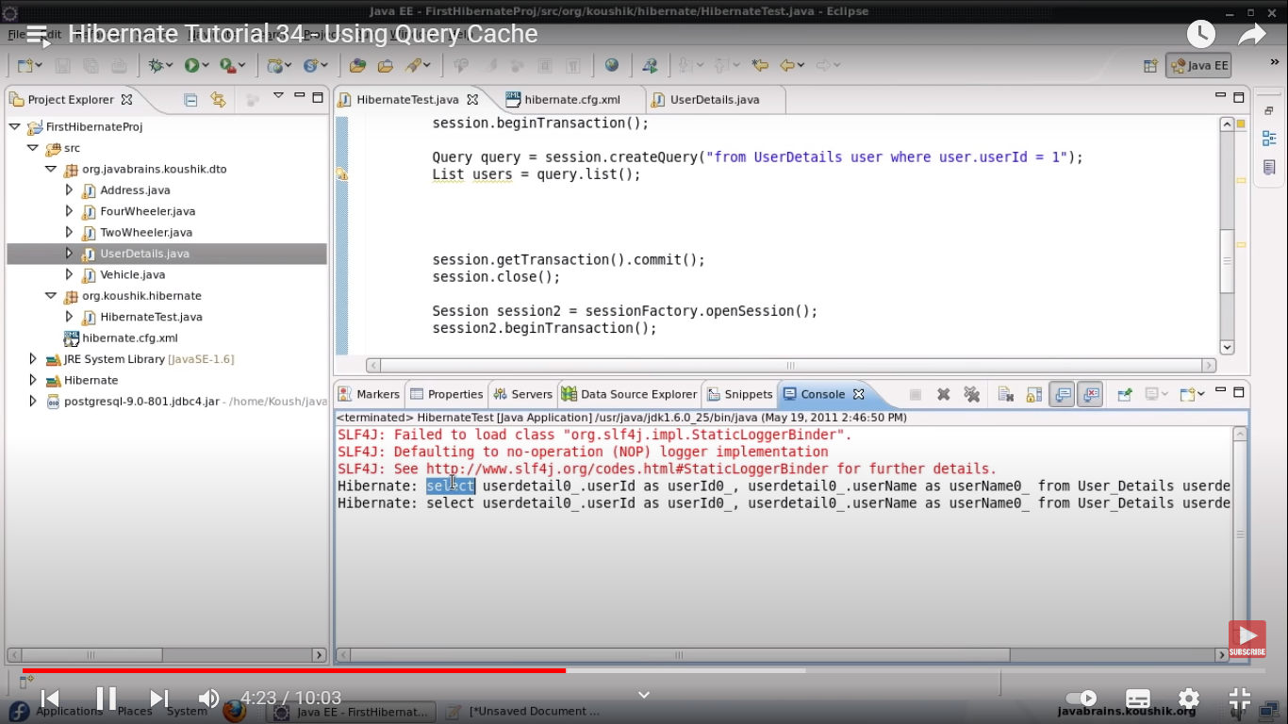

2 select queries still we have specified cache.

Hibernate differentiate query cache from other .so we need to define that as well.

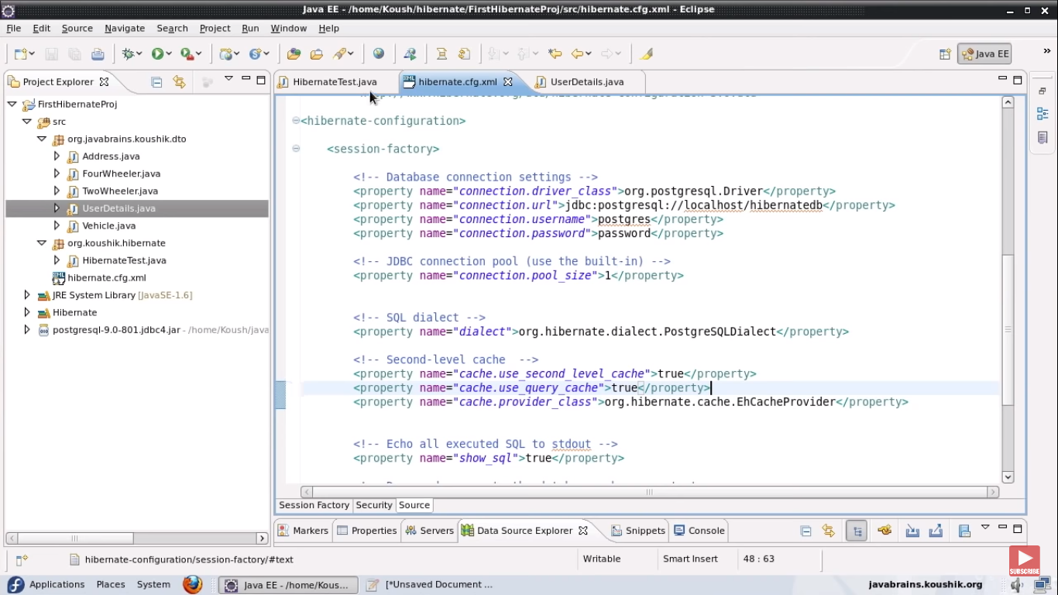

Defined query cache in cfg file.

So there are 3 caches .session , second level and query cache.

We have defined Ehcache provider

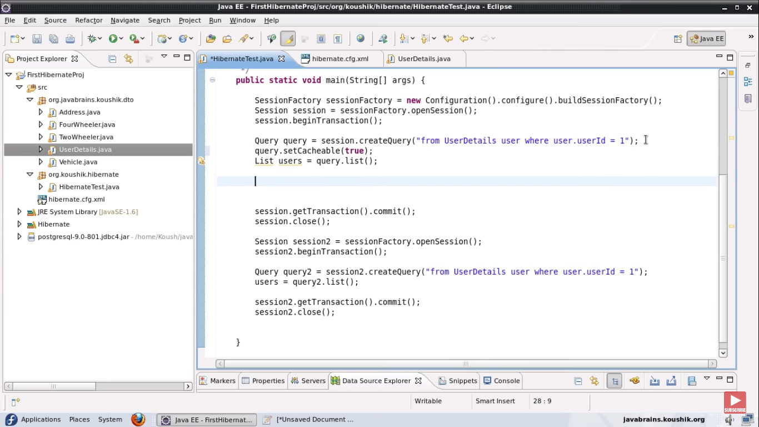

Also we have done query.setCachable to true;

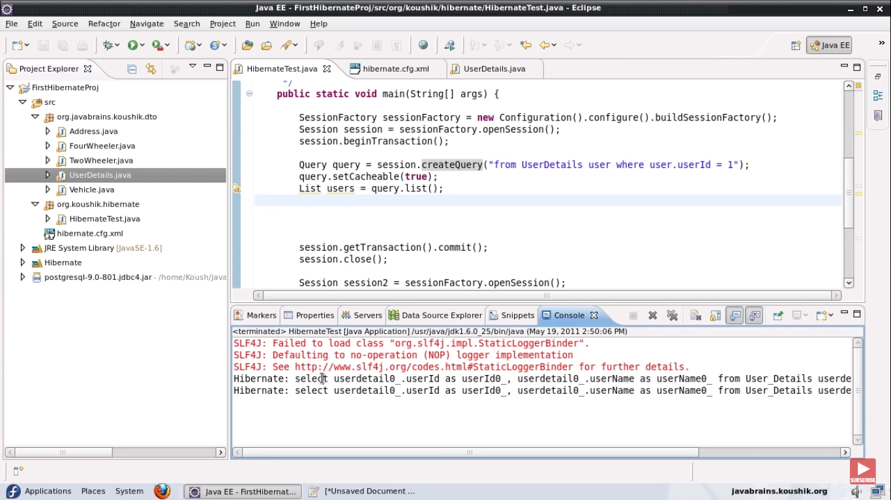

Still we are getting 2 queries .

We need to do query2.setCacheable to true as well.

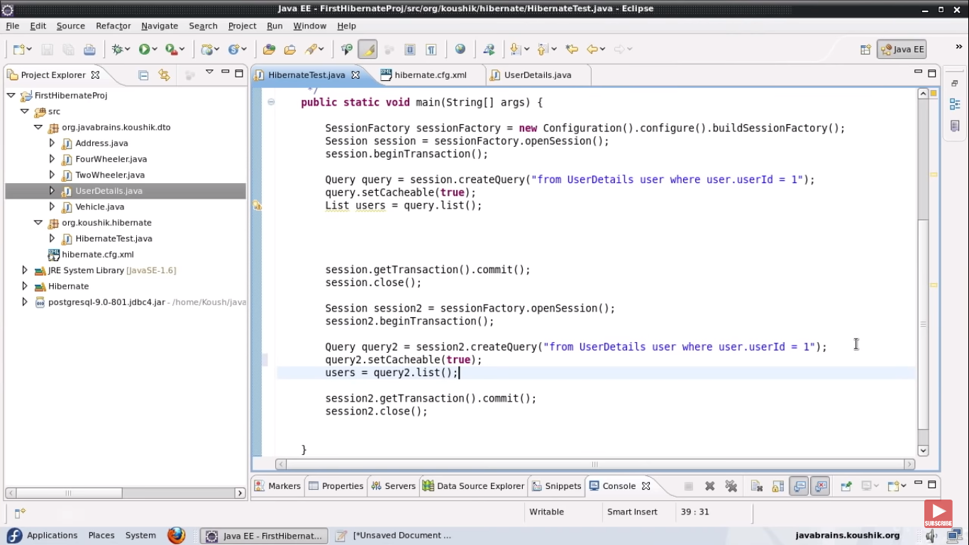

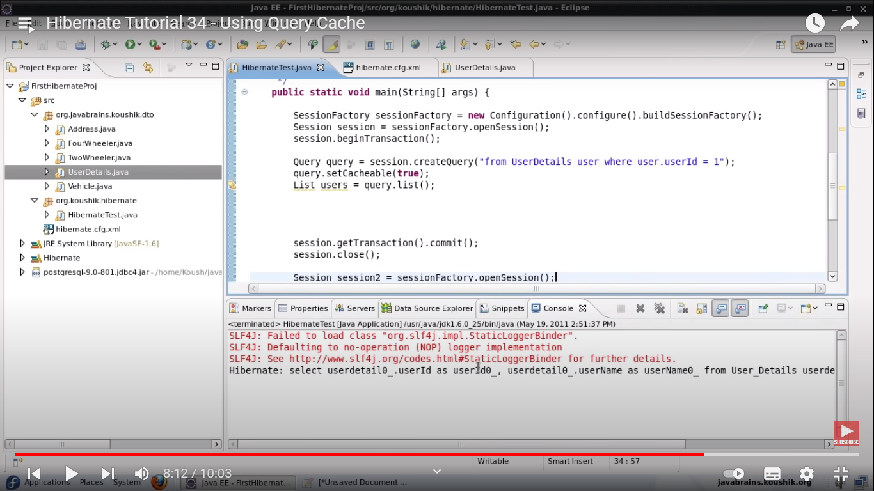

Now only one query is executed.

setCachable caches the query result and also tells the query to look at query cache .

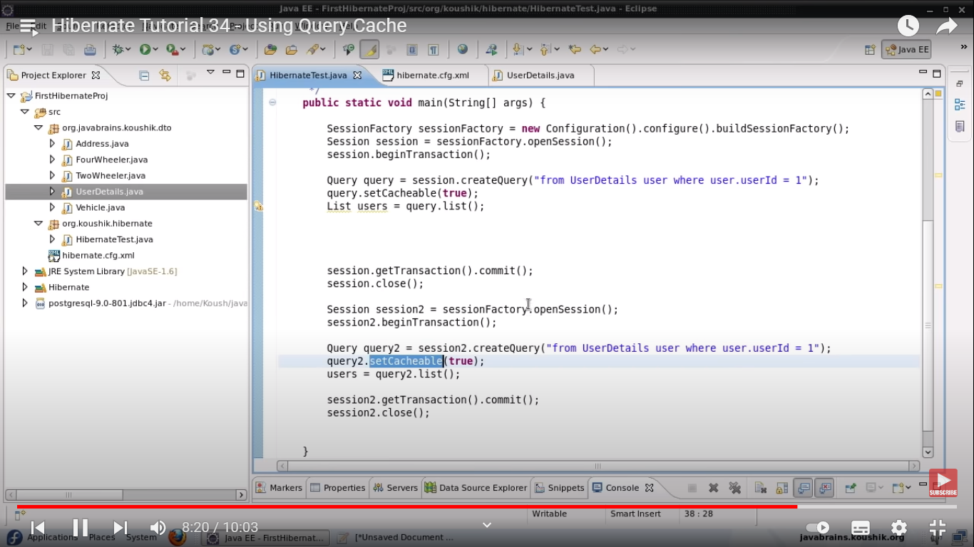

So we marked both queries as setCacheable to true.